**Merge Conflict**

* Occurs when same file modified at both branches.

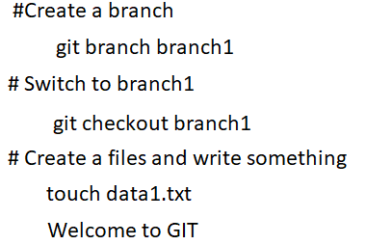

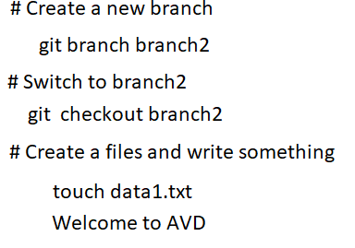

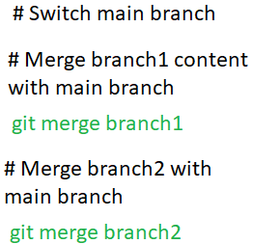



**How to Resolve Merge Conflict**

* Navigate to your local Git repository where the merge conflict occurred.
* Run git status to see which files have conflicts.
* Open the conflicting file in your favorite text editor.
* Look for the conflict markers (<<<<<<<, =======, >>>>>>>). These markers show the conflicting changes.
* Decide whether to keep your changes, the other person's changes, or a combination of both. Remove the conflict markers and make the necessary edits.
* Once you've resolved the conflicts, save the file.
* Run git add <file> to mark the conflict as resolved.
* Commit the changes with git commit